**To: Professor Drumwright**

**From: Randy Schur**

**Box homework assignment – simulating contact forces**

1. The test you suggested comes from the definition of a derivative. In the limit as the time step gets small, x_dot = x2 – x1 for any process x. In this case, we are applying the definition to rotation matrices with angle theta.
2. I wrote another version of the box_ode function, although I still used the subfunctions like drot. I thought that this would be a good exercise to understand how exactly the integrator worked. The script file simulate_contact_forces.m is the main file. The gains I used are kp = 70,000 and kv = 455.
3. See Matlab code and plot below.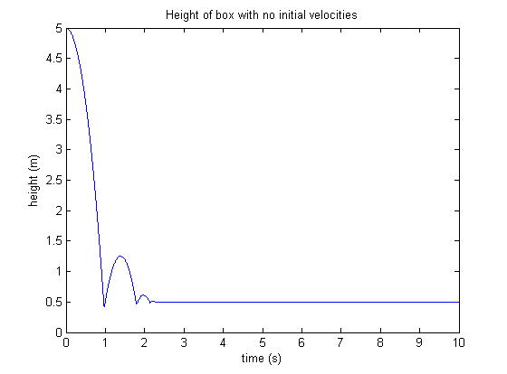
4. See Matlab code and plot below.